**Home task # 4:**

**Question #1: write all number from 1 to 150 that is not the multiple of 10.**

**#include<iostream>**

**using namespace std;**

**int main(){**

**int x;**

**cout<<"Enter the positive number :";**

**cin>>x;**

**if(x==2||x==3||x==5){**

**cout<<x<<" is a prime number";}**

**for(int i=2;i<=x;i++)**

**{ if(i%2==1&&(i%3==1||i%3==2)&&i%5!=0){**

**cout<<x<<" is not a prime number"; }**

**else{ cout<<x<<" is a prime number"; }**

**break; }**

**}**

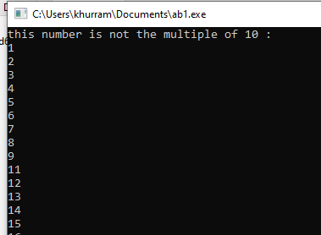

**Queation#2:**

**#include<iostream>**

**using namespace std;**

**int main(){**

**int x,i,y=0,z;**

**cout<<"insert a number"<<endl<<"first number: ";**

**cin>>x;**

**while(x>0)**

**{z=x%10;**

**y=z+y;**

**x=x/10;**

**}**

**cout<<"sum of digits are = "<<y;**

**return 0;}**

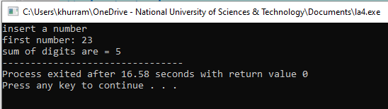

**Question #3: How to check a number is a prime number?**

**#include<iostream>**

**using namespace std;**

**Int main(){**

**int x;**

**cout<<"Enter the positive number :";**

**cin>>x;**

**if(x==2||x==3||x==5){**

**cout<<x<<" is a prime number";}**

**for(int i=2;i<=x;i++)**

**{ if(i%2==1&&(i%3==1||i%3==2)&&i%5!=0){**

**cout<<x<<" is not a prime number";}**

**else{ cout<<x<<" is a prime number";}**

**break;}**

**}**

